1. To Create a new console application in Visual Studio using Bash command

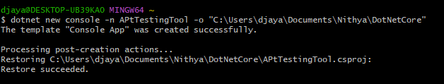

1. Go to the dir of the .prj file and install the nuget package

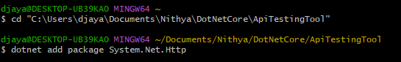



Workflow API testing:

API Endpoint: [API Web Service](https://www.weather.gov/documentation/services-web-api)

Http Methods to Test: Get, Post

Expected Input Data:

Expected Output Data: